# Host: Venue:

**Centar up2date** **University of Zadar**

Ulica Grada Mainza 29 Ul. Mihovila Pavlinovića

10000 Zagreb 23000 Zadar

Croatia Croatia

info@up2date.hr

# International Association ICC:

Klaus Miesenberger,  
University of Linz, Altenbergerstr. 69, 4040 Linz, Austria

eMail:[icc@aib.uni-linz.ac.at](mailto:icc@aib.uni-linz.ac.at)

www:<http://www.icc-camp.info>

Tel.:++43 (0) 732 2468-3757

***Your National Co-ordinator:***

**www.icc-camp.info**

✄ **Limited number of places! Send to your national co-ordinator soon!** 🖂

**International Camp on Communication and Computers 2018**

Yes, I want to take part in ICC’18!

Please send me further information / a detailed application form!

name: date of birth:

address:

postal code: city:

eMail:

tel.:

# logo_ICC_300_transparent24th ICC 2018 for Blind & Partially Sighted Youth

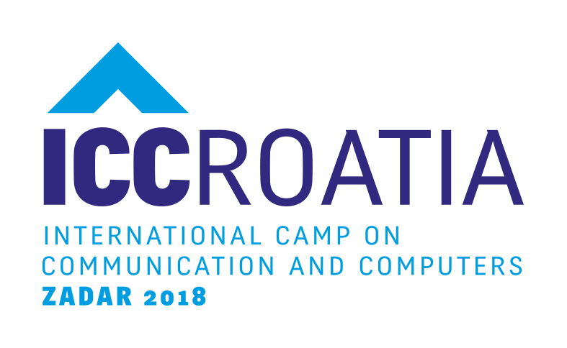

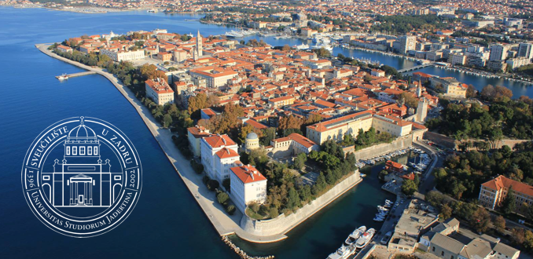

ICC 2018 in Zadar, Croatia, is a very special opportunity to learn how Information and Communication Technology (ICT) and Assistive Technologies (AT) enrich the life of blind and partially sighted people.

Students from about 15 European countries will enjoy plenty of intercultural activities, communication and networking,   
planning for future studying and   
job integration, fun and   
leisure time activities.

**16 to 21 years**

**July 22 – 31, 2018**

**Come and get involved!**

## ICC: Much More than Technology

Handling ICT and AT have become a prerequisite for blind and partially sighted persons for inclusion in education, vocational training, leisure, culture, politics, … Skills in handling ICT and AT in the information society with a growing awareness for accessibility became a key success factor.

ICC’s focus is on making use of ICT in the best way for

* interaction and communication
* integration in education (school/university)
* enhanced opportunities in the labour market
* independent living and leisure time activities

ICC is an incentive to acquire the skills needed for your own future!

ICC is international, a unique occasion to enjoy yourself and to get the feeling of being part of a greater international community of colleagues with similar interests.

## Workshops

Based on your needs and previous knowledge you are invited to select from a list of more than 20 workshops (3 and 6 hours each), focusing on

* latest ICT / AT (e.g. Internet, music, speech input, games, coding)
* social and presentation as well as daily living skills
* ICT and AT supported mobility
* managing to start to study at university
* job search and labour market integration skills
* …

National co-ordinators support you in putting together your individual workshop programme for the camp.

## Leisure Time Activities

ICC is fun! Enjoy fascinating and challenging activities you never thought of – together with peers from all around the world!

## Language

The language used at the camp is English. Having good skills in speaking English is absolutely necessary to benefit from the programme.

## Expenses

The general participation fee, covering all expenses for the camp, will not exceed € 400 per participant (travel costs are not included).

## Care

Participants enjoy the training and supervision by professionals coming from universities, schools and special organisations from all over Europe.

A trainer : participant ratio of 1 : 3 – that also applies to the varied leisure time programme (days out, swimming, games etc.) – guarantees individual support.

## Technical equipment

All equipment, including individual AT, will be made available on site.

## Organisation

ICC is managed by the International Association ICC, a non-profit organisation with national co-ordinators in more than 30 countries. Each year one partner acts as the Host of ICC.

**ICC ’18 in Zadar, Croatia is organised in co-operation with:**

 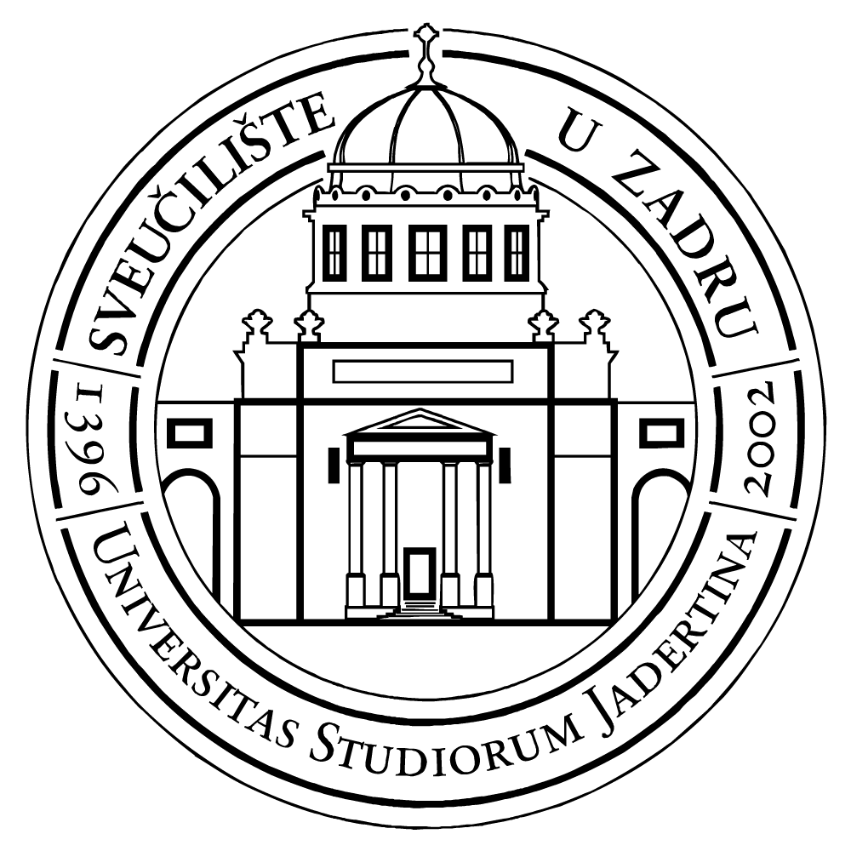  

[**http://www.icc-camp.info**](http://www.icc-camp.info)