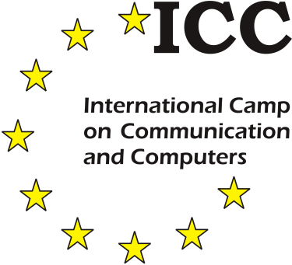Host: Venue:

VICTA RNC Hereford
5 Douglas House Venns Lane
32-34 Simpson Road Hereford HR1 1DT
Milton Keynes MK1 1BA United Kingdom
United Kingdom
lwakefield@victa.org.uk

International Association ICC:
Klaus Miesenberger,
University of Linz, Altenbergerstr. 69, 4040 Linz, Austria eMail: icc@jku.at
www: http://www.icc-camp.info Tel.: ++43 (0) 732 2468-3757

Your National Co-ordinator:
25th ICC 2019

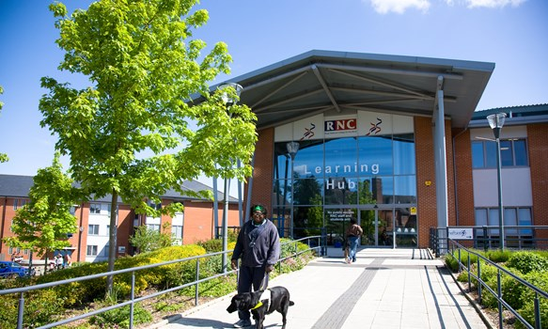for Blind & Partially Sighted Youth

www.icc-camp.info

 Limited number of places! Send to your national co -ordinator soon! 
International Camp on Communication and Computers 2019
Yes, I want to take part in ICC’19!
Please send me further information / a detailed application form!
name: date of birth: address:
postal code: city: eMail:
tel.:

ICC 2019 in Hereford, UK, is a very special opportunity to learn how Information and Communication Technology (ICT) and Assistive Technologies (AT) enrich the lives of blind and partially sighted people.
Students from about 16 different European countries will enjoy plenty of intercultural activities, communication and networking opportunities, planning for future study and job integration, together
with fun and leisure time activities.

16 to 21 years
July 22 – 31, 2019

Come and get involved!

ICC: Much More than Technology
Handling ICT and AT has become a prerequisite for blind and partially sighted people for inclusion in education, vocational training, leisure, culture and politics. Technology has not just increased accessibly for those with sight impairment but has been a key factor in building awareness for constant change within the sector.
ICC’s focus is on making use of ICT in the best way for
- interaction and communication
- integration in education (school/university)
- enhanced opportunities in the labour market
- independent living and leisure time activities
ICC is an incentive to acquire the skills needed for your own future!
ICC is international and provides a unique occasion to enjoy yourself and to get the feeling of being part of a greater international community of colleagues with similar interests.
Workshops
Based on your needs and previous knowledge you are invited to select from a list of more than 20 workshops (3 and 6 hours each), focusing on
- latest ICT / AT (e.g. Internet, music, speech input, games, coding)
- social and presentation as well as daily living skills
- ICT and AT supported mobility
- managing to start to study at university
- job search and labour market integration skills
• …
National coordinators support you in putting together your individual workshop programme for the camp.

Leisure Time Activities
ICC is fun! Participants enjoy fascinating and challenging activities they never thought of
– together with peers from all around the world!

Language
The language used at the camp is English. Having good skills in speaking English is absolutely necessary to benefit from the programme.

Expenses
The general participation fee, covering all expenses for the camp, will not exceed € 500 per participant (travel costs are not included).

Care
Participants enjoy training, guidance and supervision from professionals at universities, schools and organizations from across Europe.
A trainer : participant ratio of 1 : 3 – that also applies to the varied leisure time programme (days out, swimming, games etc.) – guarantees individual support.

Technical equipment
All equipment, including individual AT, will be made available on site.

Organisation
ICC is managed by the International Association ICC, a non-profit organisation with national coordinators in more than 30 countries. Each year one partner acts as the Host of ICC.

ICC ’19 in Hereford, UK, is organised in co-operation with:

http://www.icc-camp.info

