Workshops Driven by "Participants Choice"… Totally!
The workshops focus on hands on situations and applications – on how to manage real life situations with ICT and how to develop skills needed.
The participants choose from a rich variety of workshops held by experts working on the topic from all over the world. Those Workshops are partly taken out of evaluated results on the needs of former participants and partly from "the cutting edge" of research and practice.
There are 3 and 6 hour workshops, making up an intense programme of 6 "ICC- workshop-days":
Table 1: Example schedule for ICC

Schedule Example | Day 1 | Day 2 | Day 3 | Day 4 | Day 5 | Day 6 | Day 7 | Day 8 | Day 9 | Day 10
07.30 - 08.30 | Arrival | Break- fast | Break- fast | Break- fast | Break- fast | Break- fast | Break- fast | Break- fast | Break- fast | Departure
09.00 - 12.00 |  | Intro WS | WS | Excursion | WS | WS | WS | WS | WS
12.00 - 13.30 |  | Lunch | Lunch |  | Lunch | Lunch | Lunch | Lunch | Lunch
14.00 - 17.00 |  | WS | WS |  | WS | WS | WS | WS | Free act.
17.00 - 18.30 |  | Dinner | Dinner |  | Dinner | Dinner | Dinner | Dinner | Dinner
19.00 - 22.00 | Welcome | Leis. Time | Leis. Time | Leis. Time | Leis. Time | Leis. Time | Leis. Time | Leis. Time | Fare- well

Contact

International Association ICC
Klaus Miesenberger, University of Linz, Austria Tel.: ++43-732-2468-3751, Fax: -23751
eMail: icc(at)jku.at

National Co-ordinators promote ICC in more than 30 countries!
https://www.icc-camp.info
General Information

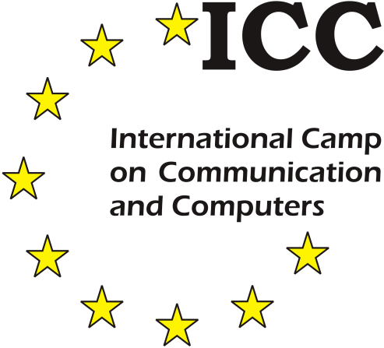
ICC – International Camp on Communication
and Computers

THE Unique Opportunity for Blind & Partially Sighted Youth The Idea ICC
The idea ICC is simple - and this simplicity seems to be its power:
It started with support centres at Linz University, Austria, and the University of Karlsruhe (TH), Germany that offer support to blind and partially sighted students in their inclusion into mainstream studying. The usage of computers has been a prerequisite from the beginning in the late 80s. Like wheelchairs – enhancing the physical mobility of the physically disabled – the computer enhances the "literal" mobility of the print disabled. It opens a door to the "digital universe" to be accessed through computers adapted to their needs. Having high skills in ICT is a must for this target group, much more than for the average population.
Additionally, the process of making a profound decision what and where to study, finding out how to structure and setting up a study or where to get support asks for counselling and supply with information. The high complexity of this process for blind and partially sighted people in terms of technical, pedagogical, as well as social aspects asks for an early start of preparation.
To be able to get in touch with possible students at an early stage, to show up higher education as possible career path, to give counselling for studying, to introduce modern ICT as a mean for successful studying and to motivate them for international and intercultural exchange is the core idea of ICC.
Of course the ICT focus changes rapidly but this core idea to accompany young students to higher education paths stays the same.

The International Camp on Communication and Computers:
- Makes visually impaired students aware of technology and their advantages, necessary computer skills, needed efforts to enhance their technical skills and the level of flexibility / mobility as well as their social skills.
- Supports the students in getting to a decision for their educational and vocational future and motivates them for an early and profound preparation before starting their career in higher education.
- Is an excellent opportunity to make contact with partially sighted and blind peers from other countries and to exchange interests and experience.
ICC should be seen as a starter for this process, giving an incentive to students to do their best to graduate at secondary school and to prepare themselves well for the entrance into Higher Education and the labour market.

The Concept ICC:
- Internationality:
- From local minorities to an international interest group
- Motivation:
- Workshops from "Introducing ICT" to “Computers&Communication”
- Self-Experience: Challenging leisure time activities
- Personal Support: Without "overprotection"
- Co-Operation & Networking: With and by recognised experts
- Awareness Raising: By, with and for the designated "target group"

Impact
It is clear that a single "Camp on Computers and Communication" is not able to solve all the issues related to the inclusion of visually impaired people – in social, political, economic, ethical, pedagogical or technical dimensions – but every change and evolution needs a starter and the necessity for such a start is obvious. ICC is proud to be motivator and enabler.
Besides this, ICC bears a broad field for experts taking part to learn - hands on, from each other, to get to know concepts and methods applied in other countries. Teachers and specialists from all over Europe accompanying the groups of students and preparing workshops have a unique opportunity to learn from other colleagues, other cultures and form a very dense network concerning their professional working area.
Last but not least ICC offers a unique chance to the local organisers to make the public aware of their work and the need for inclusion. The camps always get big audience – as „sensational events" with technical, social and international highlights
in local, national and international press, radio and TV – supporting the local organizer's PR work.
The refreshing and creative international atmosphere away from the well-known everyday (working) life, the freedom in contents and methods to concentrate on the student's necessities and abilities bring our goals into grasp.

Locations and Numbers
In the last 29 years, ICC brought together more than 2000 youth from all over the world and about 1600 experts accompanying and tutoring them.
We celebrated 25 live & 2 online ICCs in 17 countries (alphabetical order):
- Austria (1993/1994, 1995, 1996, 2009) – Linz, Graz & Vienna
- Belgium (2017) – Leuven
- Croatia (2018) – Zadar
- Czech Republic (2005, 2013) – Brno & Telč
- Finland (2007) – Espoo
- France (1998) – Lyon / Clermont-Ferrand
- Germany (2000, 2006, 2016) – Stuttgart, Königs-Wusterhausen, Dresden
- Greece (2010) – Kastri, Nea Erithrea, Athens
- Hungary (2004) – Budapest
- Italy (2011) – Florence & Ferrara
- Latvia (2014) – Riga
- Online (2021, 2022) – Worldwide
- Romania (2012) – Cluj-Napoca
- Slovenia (2001) – Škofja Loka
- Sweden (1999) – Stockholm
- Switzerland (2003) – Zollikofen
- The Netherlands (1997, 2015) – Zeist
- United Kingdom (2002, 2019) – Loughborough, Hereford
In 2023, we meet again in person at University Center Telc / Czechia for the 28th ICC!

Two main areas of knowledge, skills and competences
Experts provide user activities and workshops offering training in technical as well as social skills and competences:
- Latest technology developments for both, beginners and advanced
- Internet
- Software and Apps (all possible areas of interest
- Personal and intercultural learning, communication and wellbeing
- Integration into higher education and going abroad
- Job application, assessment and labor market integration

